CASE 1: When all servers systems had NCache Installed.
PowerShell can run NCache tools [listcaches, startcache, stopcache etc] from within PowerShell without making any changes. One can also run these commands on remote computers. But NCache must be installed on both client and server systems.

Syntax for NCache tools.
- listcaches
To list all caches on local machine, write command in Powershell.
listcaches
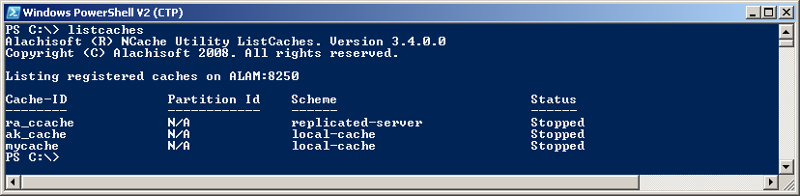

To list all caches on server test6, write command in Powershell.
listcaches /s test6
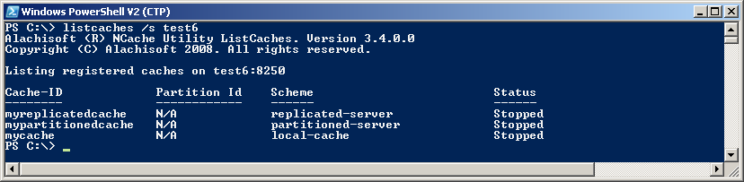

- addnode
To add a node to a clustered cache, write command in Powershell.
addnode my_clusteredcache /e server1 /n server2
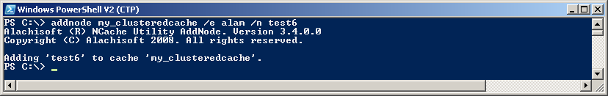

- startcache
To start a cache on local system, write command in Powershell.
startcache mycache
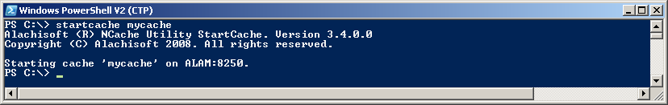
To start a cache on server test6, write command in Powershell.
startcache mycache /s test6
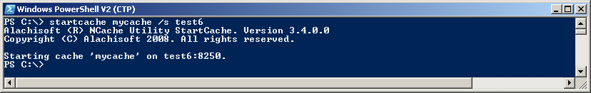

- stopcache
To stop a cache on local system, write command in Powershell.
stopcache mycache
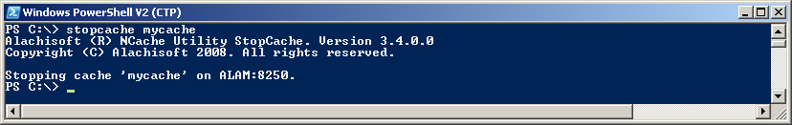

To stop a cache on server test6, write command in Powershell.
stopcache mycache /s test6
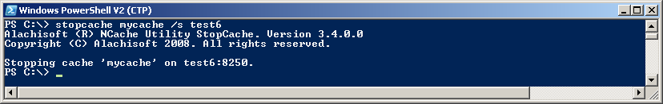

- removenode
To remove a node from a clustered cache, write command in Powershell.
removenode my_clusteredcache /s server1
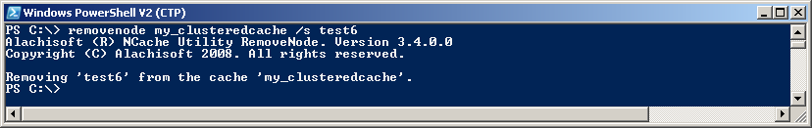

- getcachecount
To view the no of items in cache named mycache write command in Powershell.
getcachecount mycache
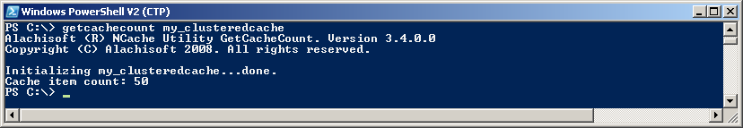

To view the no of items in cache named mycache on server1, write command in Powershell.
getcachecount mycache /s server1
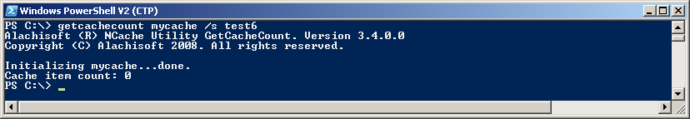

- clearcache
To clear the contents of cache named mycache write command in Powershell.
clearcache mycache
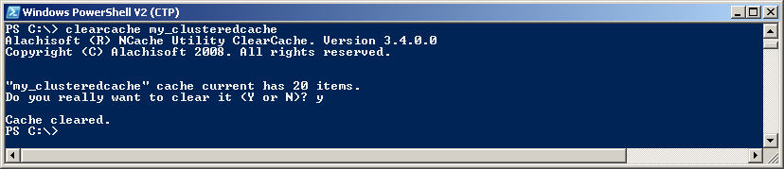

- addtestdata
To add test data to cache named mycache write command in Powershell.
addtestdata mycache
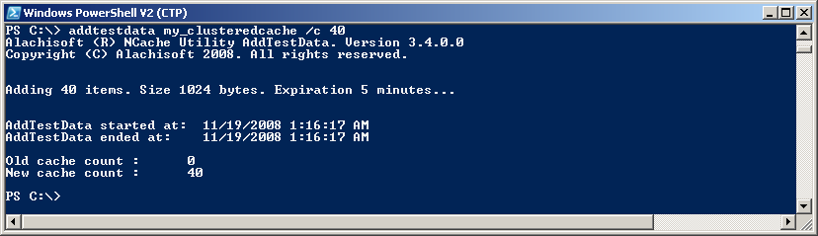

- genmackeys
To configure keys to use for encryption and decryption write command in Powershell.
genmackeys /vklen 64 /dklen 48
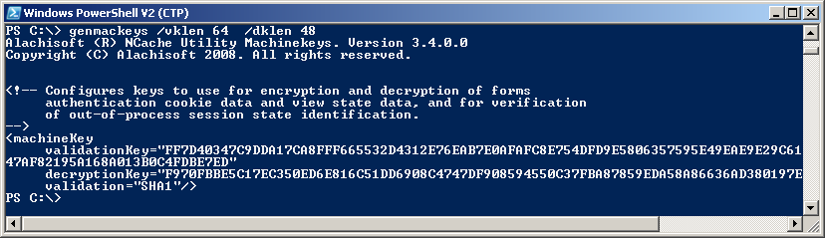
CASE 2: When some servers systems had no NCache Installed. But need to run NCache tools remotely.
To enable servers (that does not have NCache installed) to run NCache tools on remote systems (on which NCache service is running) , one need to configure some features of Powershell to enable it for running commands on remote system.

A. Configuring Powershell.
The steps for configuring Powershell are given below:

- Powershell V2 must be installed on all clients and on the server systems.
- Windows Remote Management updates for the operating system must be installed on all systems.
- Powershell dose not allow running scripts by default so to enable this feature we run this commandlet in powershell.
  - Set-executionpolicy unrestricted
To check the executuion policy has changed or not run commandlet: get-executionpolicy
The output of this commandlet will be “unrestricted”
- Now we have to configure WS Management, to configure WS Management run this script in powershell.
  - &$pshome\configure-WSman.ps1
  - If there is problem in opening the ports 80, 443. We have to start the service “SharedAccess”.
- Then we have to configure Winrm, to configure Winrm run this commandlet in powershell.
  - Winrm quickconfig.
- Now we have to add the client computers as TrustedHosts for this Server. For this task run this commandlet in powershell.
  - Winrm set winrm/config/client ‘@{TrustedHosts=”*”}’
Note: The word TrustedHosts is case sensitive.
- The steps from 2-5 should be done on all clients and server systems.
Now our powershell is ready to show its Power of remoting ……..

B. Syntax of NCache tools.
The syntax for running NCache tools in powershell on server system (that does not have NCache installed) are given below.
Note: There are mainly two different commands used by powershell to run remote operations.

- Invoke-expression –command “any_command” –computername client1 –credential username_on_client1

- Winrs -r:http://client_computer_name –u:user_name_on_client –p:password “Powershell any_Command”

The first command has the power to run a command on more then one computers which are in same workgroup or in same Domain, having the same user on all those computers. But this command always prompts for Password.
The second command allows us to give the Password in the command line, using this we can run one or more commands on only one system at one time.
It is recommended to use the second command (i-e Winrs) as it is safer and compatible with Windows Server operating systems.
Note: The user name given should have Administrative rights on that remote system.
The word Powershell in second command is must before the command name.

Given below is the list of syntax for NCache tools in powershell using both of these types of commands (Invoke-expression and Winrs).

- listcaches
Using Winrs command
Winrs -r:http://server1 –u:user_name_on_ server1 –p:password “Powershell listcaches”
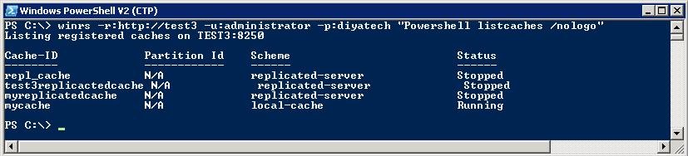

Using invoke command for single computer
Invoke-expression –command “listcaches” –computername server2 –credential username_on_server2
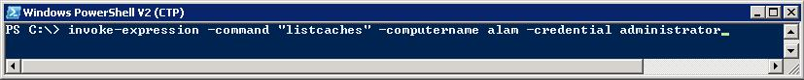
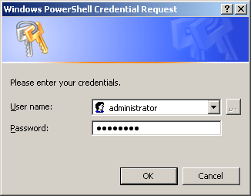
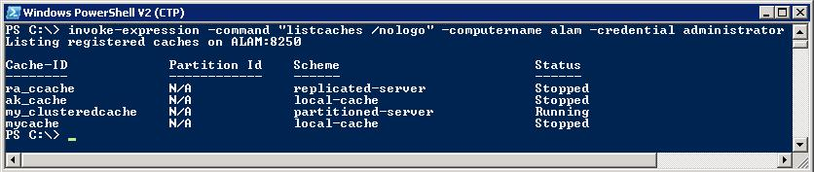

Using invoke command for multi computers
Invoke-expression –command “listcaches” –computername server2, server3 –credential comman_username_on_server2&3
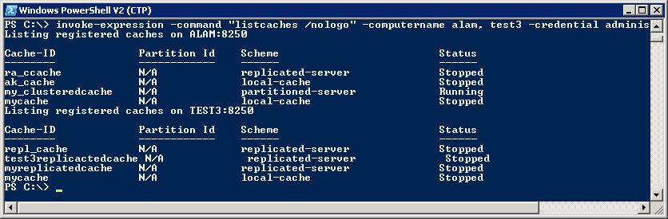

Tools like Listcaches /a , listcaches /s , listcaches /x can also be used in same way.

- addnode
Using Winrs command
Winrs -r:http://server1 –u:user_name_on_ server1 –p:password “Powershell addnode cache_name /e server1 /n server2”
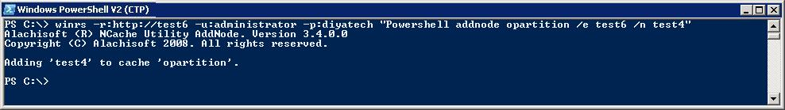

Using invoke command for single computer
Invoke-expression –command “addnode cache_name /e server1 /n server2” –computername server1 –credential username_on_server1 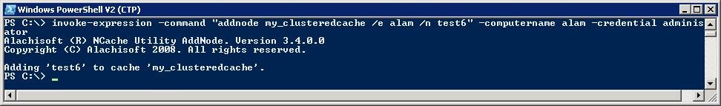

- startcache
Using Winrs command
Winrs -r:http://server1 –u:user_name_on_ server1 –p:password “Powershell startcache cache_name”
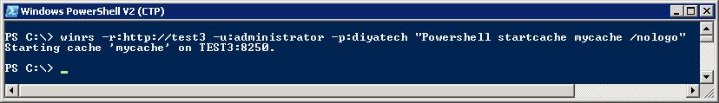

Using invoke command for single computer
Invoke-expression –command “startcache cache_name” –computername server1 –credential username_on_server1
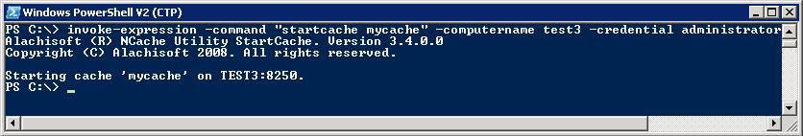

- stopcache
Using Winrs command
Winrs -r:http://server1 –u:user_name_on_ server1 –p:password “Powershell stopcache cache_name” 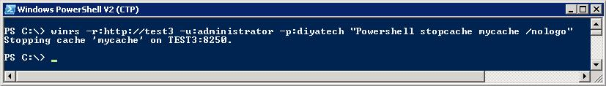

Using invoke command for single computer
Invoke-expression –command “stopcache cache_name” –computername server1 –credential username_on_server1
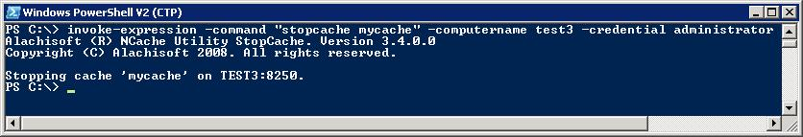

- removenode
Using Winrs command
Winrs -r:http://server1 –u:user_name_on_ server1 –p:password “Powershell removenode cache_name /s server1” 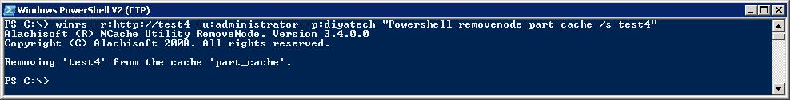
Using invoke command for single computer
Invoke-expression –command “removenode cache_name /s server1” –computername server1 –credential username_on_server1
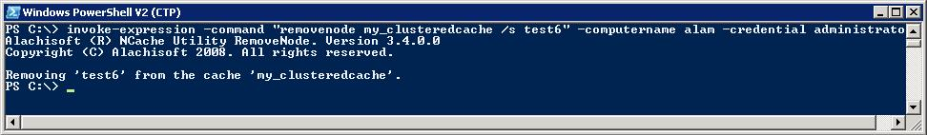

- getcachecount
Using Winrs command
Winrs -r:http://server1 –u:user_name_on_ server1 –p:password “Powershell getcachecount cache_name”
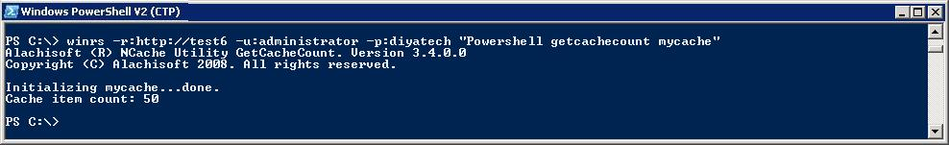

Using invoke command for single computer
Invoke-expression –command “getcachecount cache_name” –computername server1 –credential username_on_server1
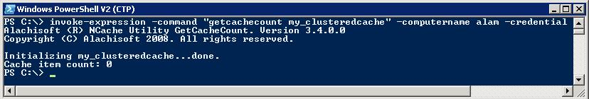

- addtestdata
Using Winrs command
Winrs -r:http://server1 –u:user_name_on_ server1 –p:password “Powershell addtestdata cache_name /c 50”
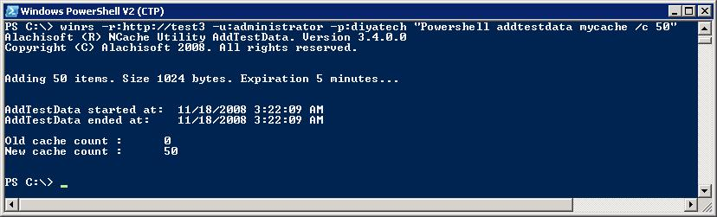

Using invoke command for single computer
Invoke-expression –command “addtestdata cache_name /c 50” –computername server1 –credential username_on_server1
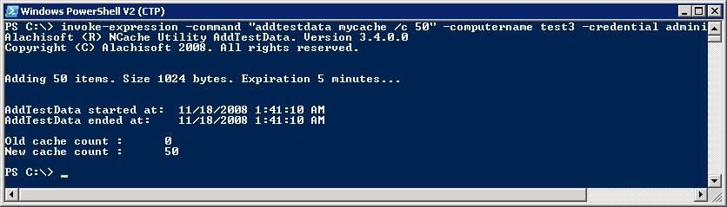

- genmackeys
Using Winrs command
Winrs -r:http://server1 –u:user_name_on_ server1 –p:password “Powershell genmackeys /vklen 64 /dklen 48”

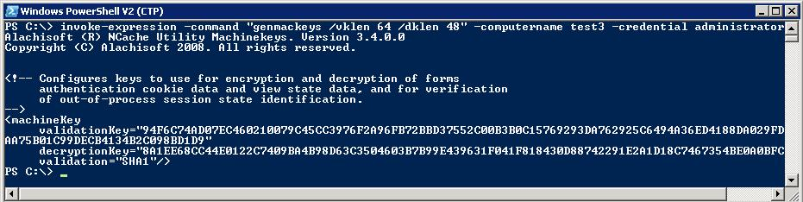

Using invoke command for single computer
Invoke-expression –command “genmackeys /vklen 64 /dklen 48” –computername server1 –credential username_on_server1

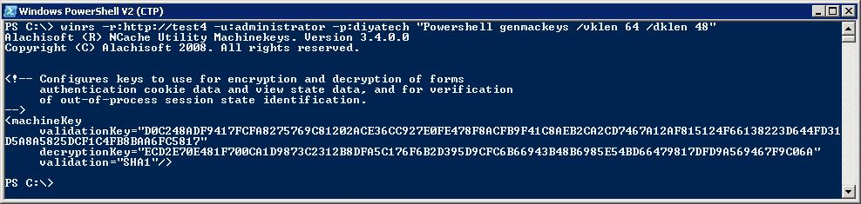

- clearcache
Using Winrs command
Winrs -r:http://server1 –u:user_name_on_ server1 –p:password “Powershell clearcache cache_name”
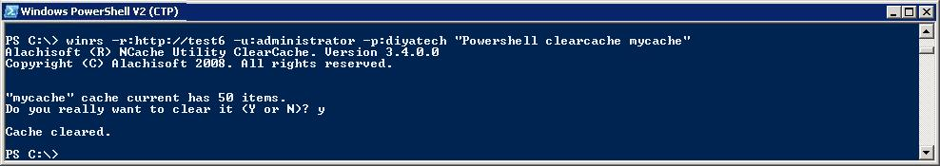

Suggestions about Powershell installation:
I had two suggestions in mind for this task.

- Either we could embed powershell inside NCache installation. i-e when some one installs NCache powershell will automatically install on that system if it is not already installed.
- Or we could provide powershell setup and Windows Remote Management updates for the operating system in form of a pack with our NCache product. The user will install them by him as prerequisites for using NCache tools remotely.

The first option is better for users but it will be more tricky and time consuming during Setup preparation of NCache.
The second option is easy to implement and the user, instead of searching the Internet for downloading Powershell and Windows Remote Management setups, can install these from pack given with NCache.

